UOG 13th MATH DAY
University of Guam, April 27, 2024
UOG CLASS Lecture Hall

PROGRAM:
8:00 – 8:30 Registration
8:30 – 8:45 Opening Remarks
8:50 – 10:10 MATH QUIZ COMPETITION Category 1 (Basic Algebra/Geometry/Statistics)
10:10 – 11:30 Category 2 (PreCalculus/Calculus)
11:30 – 11:45 Break and Refreshments
11:45 – 12:45 LECTURE: Dr. Jennifer Balakrishnan (Boston University)
12:45 – 13:00 Presentation of Awards and Final Remarks

MATH QUIZ COMPETITION
Teams from individual high schools will be asked to solve math problems and trivia questions in front of a live audience present at the event. Teams are provided with pencils and papers but are not allowed to use a calculator. Each high school can enter up to FOUR teams for each of Category 1 & 2 described above. Each team consists of TWO students. If there are too many entries, we might select less than FOUR teams from the order in the entry form (so consider ranking). One student can enter ONLY ONE of Category 1 & 2.

There will be 3 or 4 rounds in each category. In each round teams will answer 6-8 questions. ALL TEAMS WILL JOIN THE FIRST ROUND and then in each round there will be an elimination of teams. The number of rounds depends on the number of teams who participate. For example,
First round: 20 teams 10 teams
Second round: 10 teams 5 teams
Final round: 5 teams Determine the 1st, 2nd and 3rd winners who receive the prize.

LECTURE
Title: One Hundred Years of Elliptic Curves
Dr. Jennifer Balakrishnan, Boston University, USA

Abstract: An elliptic curve can be defined using an equation of the form y^2 = x^3 + ax + b. The solutions to these equations have a lot of structure, and in 1922, Mordell proved that the set of rational solutions is an important algebraic structure known as a group. Since then, elliptic curves have played a crucial role in mathematics, from the theoretical (for instance, in the proof of Fermat's Last Theorem) to the practical (in modern-day cryptography). We will describe the last hundred years of work on these curves, including a million-dollar prize problem from the 1960s that remains open. We will conclude with how machine learning has added a new angle to the study of these curves, with a computation that led to a new discovery in 2022.

Profile of Dr. Jennifer Balakrishnan

Jennifer Balakrishnan is the Clare Boothe Luce Professor of Mathematics at Boston University. She received an AB and AM from Harvard University and a PhD in Mathematics from MIT. Balakrishnan was an NSF Postdoctoral Fellow at Harvard, a Titchmarsh Research Fellow at the Mathematical Institute of the University of Oxford, and a Junior Research Fellow of Balliol College, Oxford. She is the recipient of a Sloan Research Fellowship, an NSF CAREER award, the AWM-Microsoft Research Prize in Algebra and Number Theory, a Simons Fellowship, and the AMS Birman Fellowship. Balakrishnan is a Fellow of the AMS and AWM.

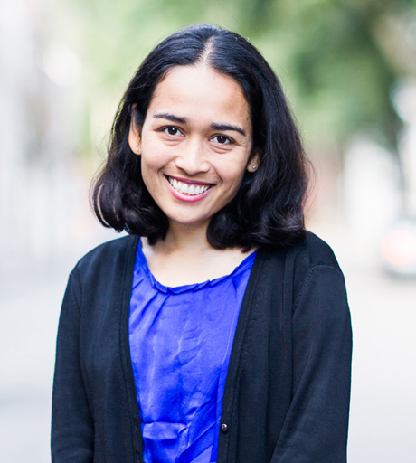

UOG 13th MATH DAY – ENTRY FORM
Please register your students NO LATER THAN Wednesday, April 17, 2024
ONLY ONE ENTRY FORM per high school

Name of High School

Name of Teachers

Name of Team Members for Quiz Competition
Category 1 (Basic Algebra/Geometry) FOUR teams (priority given to the teams with less numbers)
1
2
3
4

Category 2 (PreCalculus/Calculus) FOUR teams (priority given to the teams with less numbers)
1
2
3
4

Name of other students who will attend Math Day
Students who do not participate in the Math Quiz Competition are encouraged to attend and observe Math Day. Teachers may register students for the Math Quiz Competition and/or participate as an audience member for Math Day.

Please send this ENTRY FORM to both e-mail addresses below. If you need more information, also contact:
Hideo Nagahashi hnagahashi@triton.uog.edu 735-0137
Katrina Quinata quinatak@triton.uog.edu 735-0317
Maria Seanna Minas minasm11201@triton.uog.edu 735-2064

